**Company Data**

**Analysis**

Name: Saurabh Dharmadhikari

PGP-DSBA Online January’ 21

Table of Contents:

Problem Statement……………………...................................................................................................................................3

Data Description ............................................................................................................................................................4

Sample Data. …………………………………………………………………………………………………………………………………………….............5

Data Summary: ……………………….…………………………………………………………………………………………………………………………….7

Outliers ………………………..………………………………………………………………......…………………………………………………………........10

Missing value treatment. …………………………………….....................................................................................................13

Univariant and bivariant analysis. ..............................................................................................................................14

Scatter Plot:. …………………………………...........................................................................................................................17

Heat Map of Correlation. ............................................................................................................................................21

Train and Test Split …………………………………………………………………………........................................................................22

Linear Regression Model. …………….............................................................................................................................22

Model 1 ………………………………………………………………………………………………………………………………………………………………..24

Model 2 Using REF …………………………….………………………………………………………………………………………………………………….24

Model 3 Using SMOTE (75:25) ……………..……………………………………………………………………………………………………………….25

Model 4 SMOTE (65:35) ………………………………………………………………………………………………………………………………………..26

Model Validation …..………………………………………………………………………………………………………………………………………………26

Problem Statement

Businesses or companies can fall prey to default if they are not able to keep up their debt obligations. Defaults will lead to a lower credit rating for the company which in turn reduces its chances of getting credit in the future and may have to pay higher interests on existing debts as well as any new obligations. From an investor's point of view, he would want to invest in a company if it is capable of handling its financial obligations, can grow quickly, and is able to manage the growth scale.

A balance sheet is a financial statement of a company that provides a snapshot of what a company owns, owes, and the amount invested by the shareholders. Thus, it is an important tool that helps evaluate the performance of a business.

Data that is available includes information from the financial statement of the companies for the previous year (2015). Also, information about the Net worth of the company in the following year (2016) is provided which can be used to drive the labelled field.

Data Description:

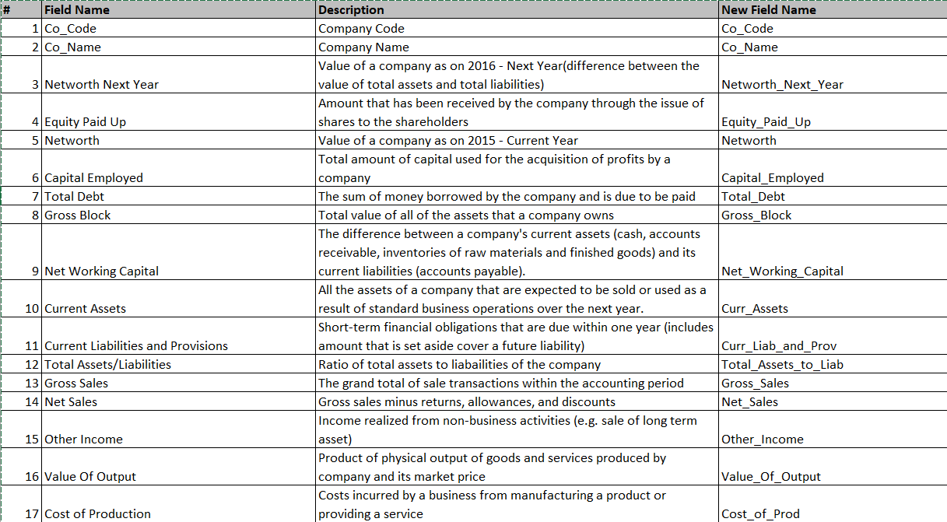

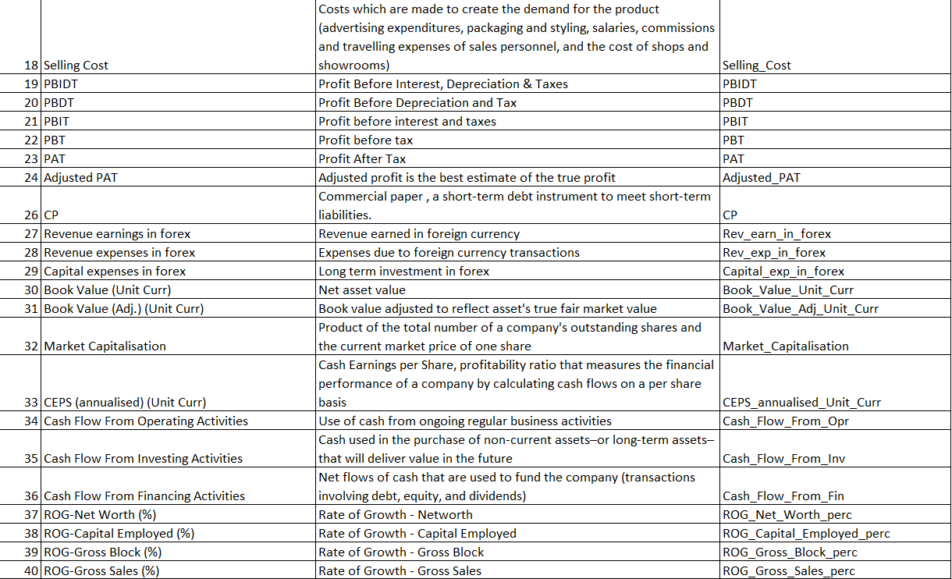

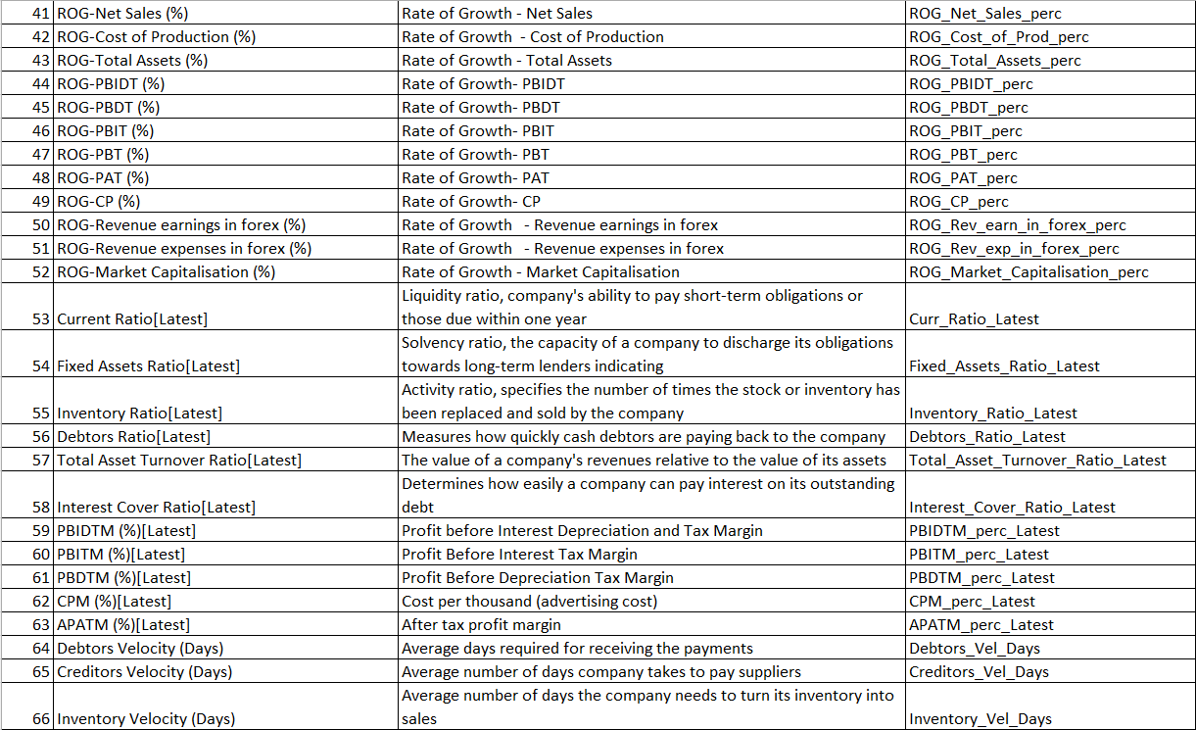



Sample Data

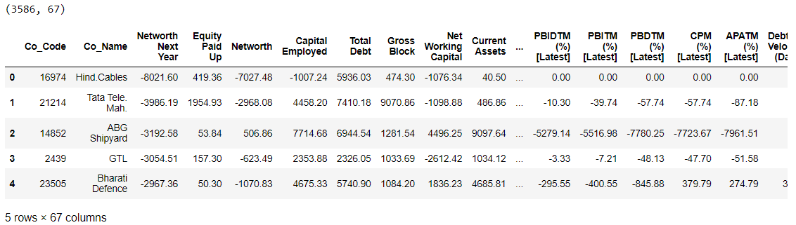

There is a total of 3586entries in our dataset and 67 columns.

There are no duplicates in this dataset.

A total of 118 null values are there.

RangeIndex: 3586 entries, 0 to 3585

Data columns (total 67 columns):

# Column Non-Null Count Dtype

--- ------ -------------- -----

0 CO_CODE 3586 non-null int64

1 CO_NAME 3586 non-null object

2 NETWORTH_NEXT_YEAR 3586 non-null float64

3 EQUITY_PAID_UP 3586 non-null float64

4 NETWORTH 3586 non-null float64

5 CAPITAL_EMPLOYED 3586 non-null float64

6 TOTAL_DEBT 3586 non-null float64

7 GROSS_BLOCK 3586 non-null float64

8 NET_WORKING_CAPITAL 3586 non-null float64

9 CURRENT_ASSETS 3586 non-null float64

10 CURRENT_LIABILITIES_AND_PROVISIONS 3586 non-null float64

11 TOTAL_ASSETS_BY_LIABILITIES 3586 non-null float64

12 GROSS_SALES 3586 non-null float64

13 NET_SALES 3586 non-null float64

14 OTHER_INCOME 3586 non-null float64

15 VALUE_OF_OUTPUT 3586 non-null float64

16 COST_OF_PRODUCTION 3586 non-null float64

17 SELLING_COST 3586 non-null float64

18 PBIDT 3586 non-null float64

19 PBDT 3586 non-null float64

20 PBIT 3586 non-null float64

21 PBT 3586 non-null float64

22 PAT 3586 non-null float64

23 ADJUSTED_PAT 3586 non-null float64

24 CP 3586 non-null float64

25 REVENUE_EARNINGS_IN_FOREX 3586 non-null float64

26 REVENUE_EXPENSES_IN_FOREX 3586 non-null float64

27 CAPITAL_EXPENSES_IN_FOREX 3586 non-null float64

28 BOOK_VALUE_UNIT_CURR 3586 non-null float64

29 BOOK_VALUE_ADJ_UNIT_CURR 3582 non-null float64

30 MARKET_CAPITALISATION 3586 non-null float64

31 CEPS_ANNUALISED_UNIT_CURR 3586 non-null float64

32 CASH_FLOW_FROM_OPERATING_ACTIVITIES 3586 non-null float64

33 CASH_FLOW_FROM_INVESTING_ACTIVITIES 3586 non-null float64

34 CASH_FLOW_FROM_FINANCING_ACTIVITIES 3586 non-null float64

35 ROG_NET_WORTH_PERC 3586 non-null float64

36 ROG_CAPITAL_EMPLOYED_PERC 3586 non-null float64

37 ROG_GROSS_BLOCK_PERC 3586 non-null float64

38 ROG_GROSS_SALES_PERC 3586 non-null float64

39 ROG_NET_SALES_PERC 3586 non-null float64

40 ROG_COST_OF_PRODUCTION_PERC 3586 non-null float64

41 ROG_TOTAL_ASSETS_PERC 3586 non-null float64

42 ROG_PBIDT_PERC 3586 non-null float64

43 ROG_PBDT_PERC 3586 non-null float64

44 ROG_PBIT_PERC 3586 non-null float64

45 ROG_PBT_PERC 3586 non-null float64

46 ROG_PAT_PERC 3586 non-null float64

47 ROG_CP_PERC 3586 non-null float64

48 ROG_REVENUE_EARNINGS_IN_FOREX_PERC 3586 non-null float64

49 ROG_REVENUE_EXPENSES_IN_FOREX_PERC 3586 non-null float64

50 ROG_MARKET_CAPITALISATION_PERC 3586 non-null float64

51 CURRENT_RATIO_LATEST 3585 non-null float64

52 FIXED_ASSETS_RATIO_LATEST 3585 non-null float64

53 INVENTORY_RATIO_LATEST 3585 non-null float64

54 DEBTORS_RATIO_LATEST 3585 non-null float64

55 TOTAL_ASSET_TURNOVER_RATIO_LATEST 3585 non-null float64

56 INTEREST_COVER_RATIO_LATEST 3585 non-null float64

57 PBIDTM_PERC_LATEST 3585 non-null float64

58 PBITM_PERC_LATEST 3585 non-null float64

59 PBDTM_PERC_LATEST 3585 non-null float64

60 CPM_PERC_LATEST 3585 non-null float64

61 APATM_PERC_LATEST 3585 non-null float64

62 DEBTORS_VELOCITY_DAYS 3586 non-null int64

63 CREDITORS_VELOCITY_DAYS 3586 non-null int64

64 INVENTORY_VELOCITY_DAYS 3483 non-null float64

65 VALUE_OF_OUTPUT_BY_TOTAL_ASSETS 3586 non-null float64

66 VALUE_OF_OUTPUT_BY_GROSS_BLOCK 3586 non-null float64

dtypes: float64(63), int64(3), object(1)

There is only 1 categorical column all other columns are numeric in nature.

**Data Summary:**

|  | **count** | **mean** | **std** | **min** | **25%** | **50%** | **75%** | **max** |
| --- | --- | --- | --- | --- | --- | --- | --- | --- |
| **CO_CODE** | 3586.00 | 16065.39 | 19776.82 | 4.00 | 3029.25 | 6077.50 | 24269.50 | 72493.00 |
| **NETWORTH_NEXT_YEAR** | 3586.00 | 725.05 | 4769.68 | -8021.60 | 3.98 | 19.02 | 123.80 | 111729.10 |
| **EQUITY_PAID_UP** | 3586.00 | 62.97 | 778.76 | 0.00 | 3.75 | 8.29 | 19.52 | 42263.46 |
| **NETWORTH** | 3586.00 | 649.75 | 4091.99 | -7027.48 | 3.89 | 18.58 | 117.30 | 81657.35 |
| **CAPITAL_EMPLOYED** | 3586.00 | 2799.61 | 26975.14 | -1824.75 | 7.60 | 39.09 | 226.60 | 714001.25 |
| **TOTAL_DEBT** | 3586.00 | 1994.82 | 23652.84 | -0.72 | 0.03 | 7.49 | 72.35 | 652823.81 |
| **GROSS_BLOCK** | 3586.00 | 594.18 | 4871.55 | -41.19 | 0.57 | 15.87 | 131.90 | 128477.59 |
| **NET_WORKING_CAPITAL** | 3586.00 | 410.81 | 6301.22 | -13162.42 | 0.94 | 10.14 | 61.17 | 223257.56 |
| **CURRENT_ASSETS** | 3586.00 | 1960.35 | 22577.57 | -0.91 | 4.00 | 24.54 | 135.28 | 721166.00 |
| **CURRENT_LIABILITIES_AND_PROVISIONS** | 3586.00 | 391.99 | 2675.00 | -0.23 | 0.73 | 9.23 | 65.65 | 83232.98 |
| **TOTAL_ASSETS_BY_LIABILITIES** | 3586.00 | 1778.45 | 11437.57 | -4.51 | 10.55 | 52.01 | 310.54 | 254737.22 |
| **GROSS_SALES** | 3586.00 | 1123.74 | 10603.70 | -62.59 | 1.44 | 31.21 | 242.25 | 474182.94 |
| **NET_SALES** | 3586.00 | 1079.70 | 9996.57 | -62.59 | 1.44 | 30.44 | 234.44 | 443775.16 |
| **OTHER_INCOME** | 3586.00 | 48.73 | 426.04 | -448.72 | 0.02 | 0.45 | 3.64 | 14143.40 |
| **VALUE_OF_OUTPUT** | 3586.00 | 1077.19 | 9843.88 | -119.10 | 1.41 | 30.89 | 235.84 | 435559.09 |
| **COST_OF_PRODUCTION** | 3586.00 | 798.54 | 9076.70 | -22.65 | 0.94 | 25.99 | 189.55 | 419913.50 |
| **SELLING_COST** | 3586.00 | 25.55 | 194.24 | 0.00 | 0.00 | 0.16 | 3.88 | 5283.91 |
| **PBIDT** | 3586.00 | 248.18 | 1949.59 | -4655.14 | 0.04 | 2.04 | 23.52 | 42059.26 |
| **PBDT** | 3586.00 | 116.27 | 956.20 | -5874.53 | 0.00 | 0.80 | 12.95 | 23215.00 |
| **PBIT** | 3586.00 | 217.66 | 1850.97 | -4812.95 | 0.00 | 1.15 | 16.67 | 41402.96 |
| **PBT** | 3586.00 | 85.75 | 799.93 | -6032.34 | -0.06 | 0.31 | 7.42 | 16798.00 |
| **PAT** | 3586.00 | 61.22 | 620.30 | -6032.34 | -0.06 | 0.26 | 5.54 | 13383.39 |
| **ADJUSTED_PAT** | 3586.00 | 60.06 | 580.43 | -4418.72 | -0.09 | 0.21 | 5.34 | 13384.11 |
| **CP** | 3586.00 | 91.73 | 780.79 | -5874.53 | 0.00 | 0.74 | 10.91 | 20760.20 |
| **REVENUE_EARNINGS_IN_FOREX** | 3586.00 | 131.17 | 1150.73 | 0.00 | 0.00 | 0.00 | 7.20 | 46158.00 |
| **REVENUE_EXPENSES_IN_FOREX** | 3586.00 | 256.33 | 4132.34 | 0.00 | 0.00 | 0.00 | 6.99 | 193979.73 |
| **CAPITAL_EXPENSES_IN_FOREX** | 3586.00 | 7.66 | 111.43 | 0.00 | 0.00 | 0.00 | 0.00 | 3722.10 |
| **BOOK_VALUE_UNIT_CURR** | 3586.00 | 157.24 | 1622.66 | -3371.57 | 7.96 | 21.66 | 71.67 | 75790.00 |
| **BOOK_VALUE_ADJ_UNIT_CURR** | 3582.00 | 2243.15 | 128283.73 | -33715.70 | 7.06 | 18.93 | 60.01 | 7677600.29 |
| **MARKET_CAPITALISATION** | 3586.00 | 1664.09 | 12805.17 | 0.00 | 0.00 | 8.37 | 111.46 | 260865.08 |
| **CEPS_ANNUALISED_UNIT_CURR** | 3586.00 | 36.02 | 828.42 | -1808.00 | 0.00 | 1.15 | 8.77 | 45438.44 |
| **CASH_FLOW_FROM_OPERATING_ACTIVITIES** | 3586.00 | 65.77 | 1455.05 | -25469.23 | -0.31 | 0.45 | 12.65 | 44529.40 |
| **CASH_FLOW_FROM_INVESTING_ACTIVITIES** | 3586.00 | -60.87 | 701.97 | -23843.45 | -5.12 | -0.12 | 0.12 | 3732.98 |
| **CASH_FLOW_FROM_FINANCING_ACTIVITIES** | 3586.00 | 11.44 | 1272.26 | -38374.04 | -5.85 | 0.00 | 0.46 | 28846.00 |
| **ROG_NET_WORTH_PERC** | 3586.00 | 1237.62 | 41041.93 | -14485.71 | -1.49 | 1.84 | 11.36 | 2144020.00 |
| **ROG_CAPITAL_EMPLOYED_PERC** | 3586.00 | 2988.88 | 126472.87 | -8614.63 | -3.83 | 1.38 | 12.59 | 7412700.00 |
| **ROG_GROSS_BLOCK_PERC** | 3586.00 | 37.55 | 893.62 | -116.12 | 0.00 | 0.25 | 6.72 | 47400.00 |
| **ROG_GROSS_SALES_PERC** | 3586.00 | 242.67 | 6103.53 | -5503.70 | -8.08 | 3.31 | 21.53 | 320200.00 |
| **ROG_NET_SALES_PERC** | 3586.00 | 242.59 | 6103.49 | -5503.70 | -8.12 | 3.21 | 21.57 | 320200.00 |
| **ROG_COST_OF_PRODUCTION_PERC** | 3586.00 | 310.49 | 5573.22 | -2130.23 | -7.24 | 4.42 | 23.12 | 267150.00 |
| **ROG_TOTAL_ASSETS_PERC** | 3586.00 | 2793.28 | 125941.65 | -136.13 | -3.97 | 1.48 | 12.50 | 7422120.00 |
| **ROG_PBIDT_PERC** | 3586.00 | 375.85 | 23278.40 | -52200.00 | -23.36 | 4.57 | 47.88 | 1386200.00 |
| **ROG_PBDT_PERC** | 3586.00 | 336.38 | 20353.40 | -52200.00 | -30.60 | 3.37 | 52.91 | 1208700.00 |
| **ROG_PBIT_PERC** | 3586.00 | 374.70 | 22462.79 | -58500.00 | -31.35 | 2.13 | 50.14 | 1338000.00 |
| **ROG_PBT_PERC** | 3586.00 | 224.07 | 19659.23 | -78900.00 | -41.23 | 0.03 | 61.96 | 1160500.00 |
| **ROG_PAT_PERC** | 3586.00 | 112.23 | 13480.52 | -114500.00 | -43.73 | 0.00 | 65.35 | 774200.00 |
| **ROG_CP_PERC** | 3586.00 | 221.09 | 13980.20 | -52200.00 | -29.51 | 4.62 | 52.91 | 822400.00 |
| **ROG_REVENUE_EARNINGS_IN_FOREX_PERC** | 3586.00 | 37.23 | 658.67 | -100.00 | 0.00 | 0.00 | 0.00 | 29084.77 |
| **ROG_REVENUE_EXPENSES_IN_FOREX_PERC** | 3586.00 | 364.86 | 15233.64 | -100.00 | 0.00 | 0.00 | 0.00 | 894591.69 |
| **ROG_MARKET_CAPITALISATION_PERC** | 3586.00 | 63.68 | 1047.93 | -98.05 | 0.00 | 0.00 | 47.52 | 61865.26 |
| **CURRENT_RATIO_LATEST** | 3585.00 | 12.06 | 108.41 | 0.00 | 0.88 | 1.36 | 2.77 | 4813.00 |
| **FIXED_ASSETS_RATIO_LATEST** | 3585.00 | 51.54 | 681.15 | 0.00 | 0.27 | 1.56 | 4.74 | 22172.00 |
| **INVENTORY_RATIO_LATEST** | 3585.00 | 37.80 | 458.19 | 0.00 | 0.00 | 3.56 | 8.94 | 15472.00 |
| **DEBTORS_RATIO_LATEST** | 3585.00 | 33.03 | 489.56 | 0.00 | 0.42 | 3.82 | 8.52 | 22992.67 |
| **TOTAL_ASSET_TURNOVER_RATIO_LATEST** | 3585.00 | 1.24 | 2.67 | 0.00 | 0.07 | 0.60 | 1.55 | 57.75 |
| **INTEREST_COVER_RATIO_LATEST** | 3585.00 | 16.39 | 351.74 | -5450.00 | 0.00 | 1.08 | 3.71 | 18639.40 |
| **PBIDTM_PERC_LATEST** | 3585.00 | -51.16 | 1795.13 | -78870.45 | 0.00 | 8.07 | 18.99 | 19233.33 |
| **PBITM_PERC_LATEST** | 3585.00 | -109.21 | 3057.64 | -141600.00 | 0.00 | 5.23 | 14.29 | 19195.70 |
| **PBDTM_PERC_LATEST** | 3585.00 | -311.57 | 10921.59 | -590500.00 | 0.00 | 4.69 | 14.11 | 15640.00 |
| **CPM_PERC_LATEST** | 3585.00 | -307.01 | 10676.15 | -572000.00 | 0.00 | 3.89 | 11.39 | 15640.00 |
| **APATM_PERC_LATEST** | 3585.00 | -365.06 | 12500.05 | -688600.00 | 0.00 | 1.59 | 7.41 | 15266.67 |
| **DEBTORS_VELOCITY_DAYS** | 3586.00 | 603.89 | 10636.76 | 0.00 | 8.00 | 49.00 | 106.00 | 514721.00 |
| **CREDITORS_VELOCITY_DAYS** | 3586.00 | 2057.85 | 54169.48 | 0.00 | 8.00 | 39.00 | 89.00 | 2034145.00 |
| **INVENTORY_VELOCITY_DAYS** | 3483.00 | 79.64 | 137.85 | -199.00 | 0.00 | 35.00 | 96.00 | 996.00 |
| **VALUE_OF_OUTPUT_BY_TOTAL_ASSETS** | 3586.00 | 0.82 | 1.20 | -0.33 | 0.07 | 0.48 | 1.16 | 17.63 |
| **VALUE_OF_OUTPUT_BY_GROSS_BLOCK** | 3586.00 | 61.88 | 976.82 | -61.00 | 0.27 | 1.53 | 4.91 | 43404.00 |

Let us see the outliers in our dataset.

**Outliers:**

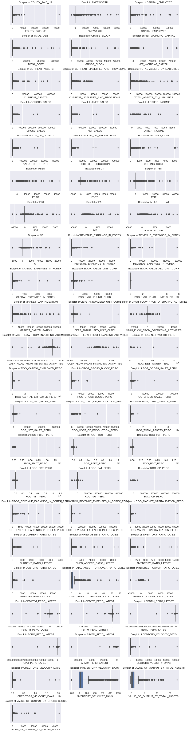

There are outliers in all our features.

We will be considering an outlier as 3rd quartile + 1.5 *IQR and 1st quartile – 1.5*IQR.

Inter Quartile = Q3 – Q1

Quantum of outliers for features:

ROG_REVENUE_EXPENSES_IN_FOREX_PERC 45.04

ROG_REVENUE_EARNINGS_IN_FOREX_PERC 36.73

CASH_FLOW_FROM_FINANCING_ACTIVITIES 28.03

PAT 26.74

ADJUSTED_PAT 26.60

PBT 26.24

APATM_PERC_LATEST 26.05

CASH_FLOW_FROM_INVESTING_ACTIVITIES 24.43

ROG_GROSS_BLOCK_PERC 23.15

CP 22.76

PBDT 22.73

CASH_FLOW_FROM_OPERATING_ACTIVITIES 22.34

ROG_NET_WORTH_PERC 20.83

REVENUE_EARNINGS_IN_FOREX 20.58

INTEREST_COVER_RATIO_LATEST 20.25

CPM_PERC_LATEST 20.11

PBIT 20.08

PBITM_PERC_LATEST 20.02

PBDTM_PERC_LATEST 19.41

CAPITAL_EXPENSES_IN_FOREX 19.35

REVENUE_EXPENSES_IN_FOREX 19.33

ROG_COST_OF_PRODUCTION_PERC 18.82

ROG_GROSS_SALES_PERC 18.71

PBIDT 18.71

ROG_NET_SALES_PERC 18.60

NETWORTH 18.13

MARKET_CAPITALISATION 17.82

ROG_CP_PERC 17.76

ROG_PBDT_PERC 17.51

NET_WORKING_CAPITAL 17.43

ROG_PBIT_PERC 17.18

ROG_PBIDT_PERC 17.04

ROG_PBT_PERC 17.04

SELLING_COST 16.87

OTHER_INCOME 16.82

CEPS_ANNUALISED_UNIT_CURR 16.79

ROG_PAT_PERC 16.68

CAPITAL_EMPLOYED 16.62

PBIDTM_PERC_LATEST 16.62

TOTAL_DEBT 16.26

CURRENT_LIABILITIES_AND_PROVISIONS 16.20

CURRENT_ASSETS 16.09

TOTAL_ASSETS_BY_LIABILITIES 16.01

ROG_CAPITAL_EMPLOYED_PERC 15.95

CURRENT_RATIO_LATEST 15.78

COST_OF_PRODUCTION 15.62

VALUE_OF_OUTPUT 15.59

NET_SALES 15.50

GROSS_SALES 15.45

GROSS_BLOCK 15.06

ROG_MARKET_CAPITALISATION_PERC 13.86

FIXED_ASSETS_RATIO_LATEST 13.83

BOOK_VALUE_ADJ_UNIT_CURR 13.66

BOOK_VALUE_UNIT_CURR 13.52

ROG_TOTAL_ASSETS_PERC 13.47

VALUE_OF_OUTPUT_BY_GROSS_BLOCK 13.41

EQUITY_PAID_UP 12.49

DEBTORS_VELOCITY_DAYS 11.10

CREDITORS_VELOCITY_DAYS 10.90

INVENTORY_RATIO_LATEST 10.49

DEBTORS_RATIO_LATEST 10.37

INVENTORY_VELOCITY_DAYS 10.18

TOTAL_ASSET_TURNOVER_RATIO_LATEST 5.63

VALUE_OF_OUTPUT_BY_TOTAL_ASSETS 4.18

dtype: float64

Thus, above are all outliers in our columns. All outliers are replaced with null value.

**Missing value treatment:**

There is a lot of missing values in our dataset so we will have treated the data and replace the missing values.

We will also convert our target variable to binary variable (1 & 0). 0 is Net_worth_next_year >= 0 and 1 is Net_worth_next_year < 0.

We are removing 2 columns with max missing values.

ROG_REVENUE_EXPENSES_IN_FOREX_PERC 45.04

ROG_REVENUE_EARNINGS_IN_FOREX_PERC 36.73

Missing values have been treated using KNN.

Target variable after conversion:

Proportion of Default in the dataset

0 3043

1 543

Name: default, dtype: int64

0 84.86

1 15.14

Name: default, dtype: float64

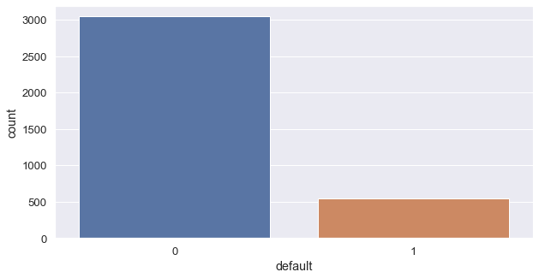

**Univariant and bivariant analysis:**

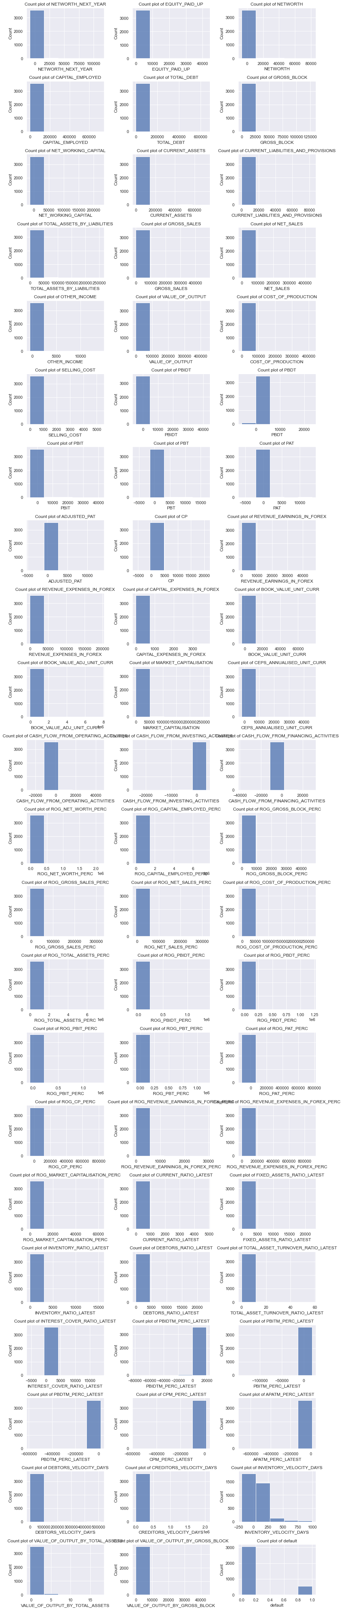

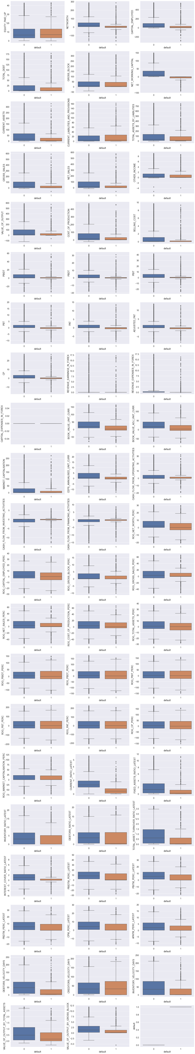

We can make out with univariant chart that most data is very skewed.

Most companies are able to convert their inventory to sales in short period.

With the bivariant analysis charts we can easily see that the difference in companies that are doing well and those that are not doing well and how features can indicate the defaulting companies.

Companies that may default have low values in:

* Net Worth
* Capital Employed
* Net Working Capital
* Current Assets
* Total Assets by Liabilities
* Gross Sales
* Net Sales
* Selling Cost
* Value of Output
* Cost of Production
* PBIDT
* PBT
* Adjusted PAT
* CP
* Book Value of Adjusted Unit Currency

**Scatter Plot:**

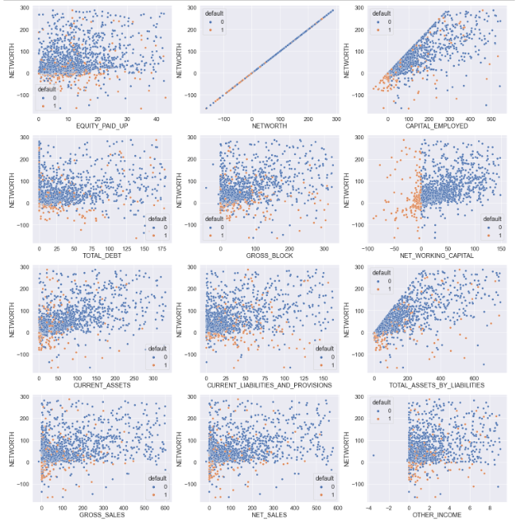

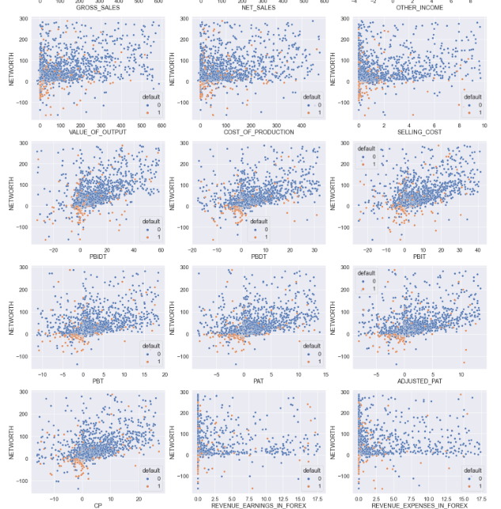

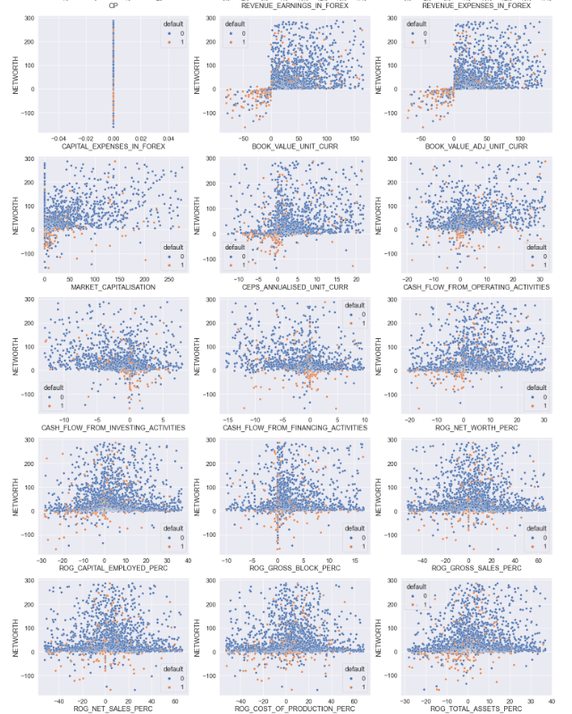

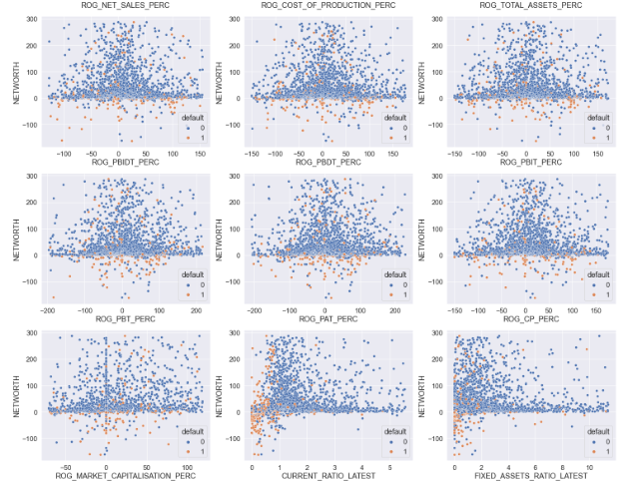

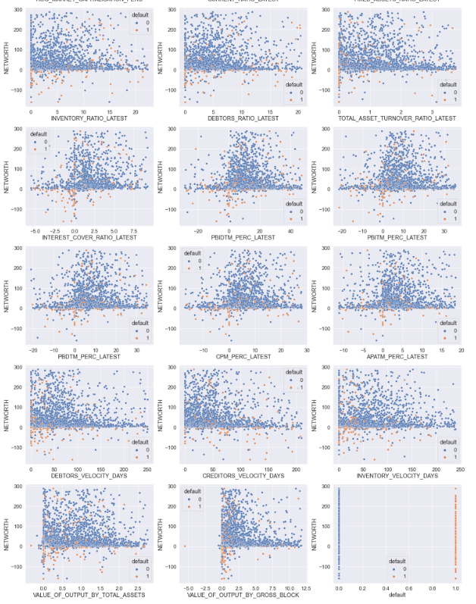

Here orange dot indicates defaulting companies in comparison to their current net worth.

We can see that orange dots for defaulting companies are at the bottom of the charts.

**Heat Map of correlation:**

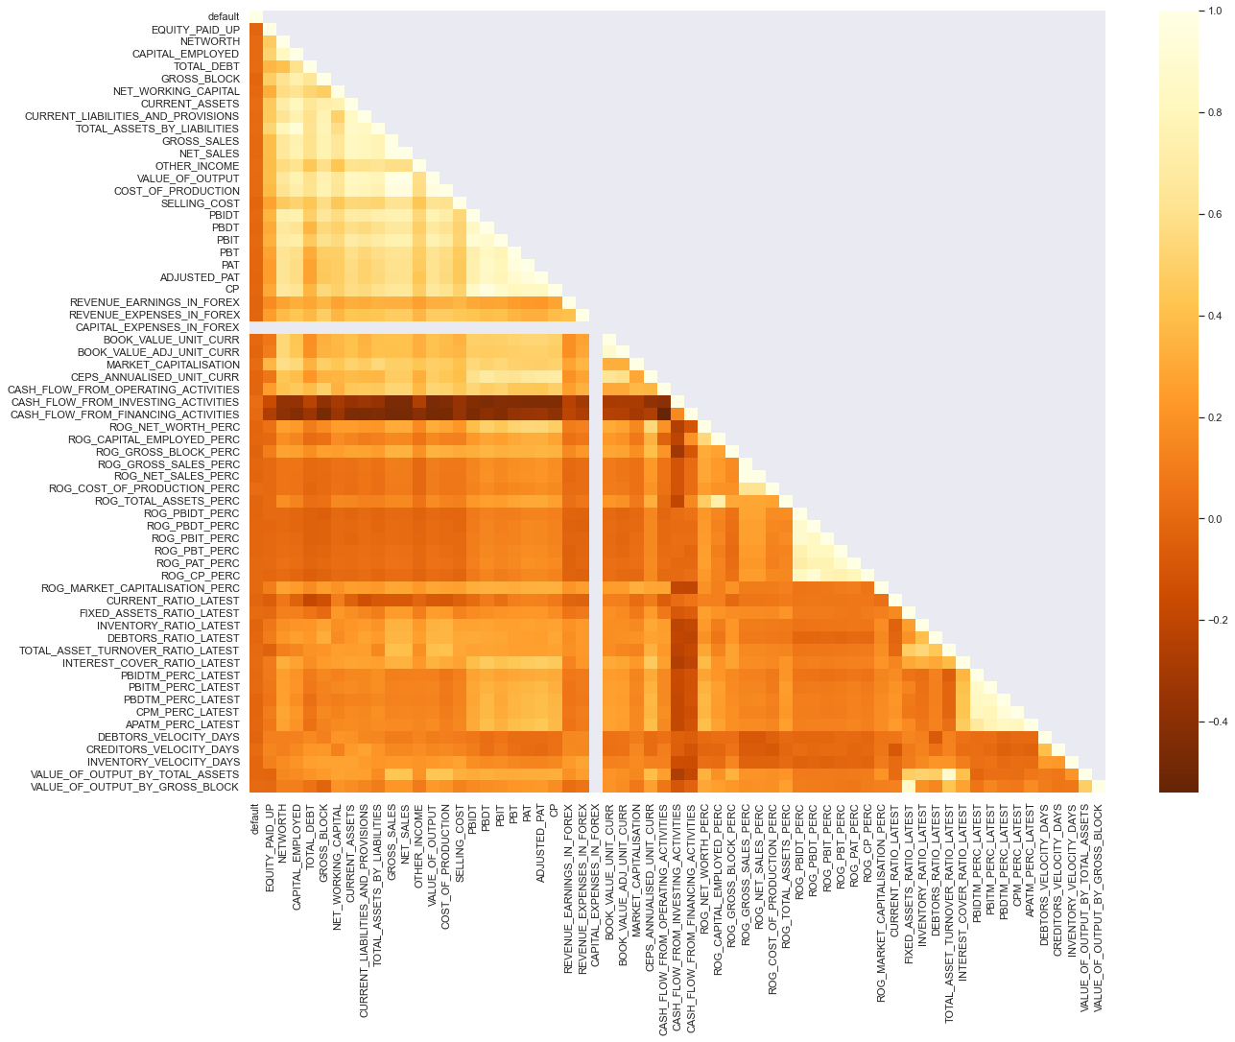

There is a lot of positive correlation between the features in the data.

**Train and Test:**

We have split the data in 67:33 ratio.

**Logistic Regression Model:**

We will use VIF method to know the features that have high multicollinearity.

|  | **VIF** |
| --- | --- |
| **NET_SALES** | 217.62 |
| **VALUE_OF_OUTPUT** | 143.10 |
| **GROSS_SALES** | 85.34 |
| **ROG_GROSS_SALES_PERC** | 79.00 |
| **ROG_NET_SALES_PERC** | 78.75 |
| **PAT** | 20.28 |
| **PBDT** | 19.71 |
| **CP** | 17.28 |
| **COST_OF_PRODUCTION** | 16.67 |
| **TOTAL_ASSETS_BY_LIABILITIES** | 13.65 |
| **PBT** | 11.65 |
| **CAPITAL_EMPLOYED** | 11.00 |
| **PBDTM_PERC_LATEST** | 10.95 |
| **ADJUSTED_PAT** | 10.83 |
| **ROG_PBDT_PERC** | 10.69 |
| **CURRENT_ASSETS** | 10.36 |
| **PBIT** | 10.09 |
| **CPM_PERC_LATEST** | 9.00 |
| **PBIDT** | 8.34 |
| **ROG_CP_PERC** | 8.05 |
| **ROG_PBIDT_PERC** | 7.38 |
| **ROG_PBT_PERC** | 6.81 |
| **CURRENT_LIABILITIES_AND_PROVISIONS** | 6.78 |
| **ROG_PBIT_PERC** | 6.65 |
| **PBITM_PERC_LATEST** | 6.31 |
| **VALUE_OF_OUTPUT_BY_TOTAL_ASSETS** | 6.12 |
| **TOTAL_ASSET_TURNOVER_RATIO_LATEST** | 5.76 |
| **PBIDTM_PERC_LATEST** | 5.67 |
| **ROG_PAT_PERC** | 5.65 |
| **BOOK_VALUE_UNIT_CURR** | 5.60 |
| **BOOK_VALUE_ADJ_UNIT_CURR** | 5.19 |
| **NETWORTH** | 4.92 |
| **GROSS_BLOCK** | 4.51 |
| **FIXED_ASSETS_RATIO_LATEST** | 4.44 |
| **VALUE_OF_OUTPUT_BY_GROSS_BLOCK** | 4.43 |
| **APATM_PERC_LATEST** | 4.12 |
| **NET_WORKING_CAPITAL** | 3.38 |
| **CEPS_ANNUALISED_UNIT_CURR** | 3.34 |
| **ROG_CAPITAL_EMPLOYED_PERC** | 2.63 |
| **TOTAL_DEBT** | 2.46 |
| **ROG_TOTAL_ASSETS_PERC** | 2.37 |
| **ROG_NET_WORTH_PERC** | 2.24 |
| **OTHER_INCOME** | 2.01 |
| **SELLING_COST** | 1.99 |
| **CASH_FLOW_FROM_OPERATING_ACTIVITIES** | 1.99 |
| **CASH_FLOW_FROM_FINANCING_ACTIVITIES** | 1.90 |
| **MARKET_CAPITALISATION** | 1.89 |
| **INTEREST_COVER_RATIO_LATEST** | 1.80 |
| **ROG_COST_OF_PRODUCTION_PERC** | 1.71 |
| **EQUITY_PAID_UP** | 1.64 |
| **REVENUE_EXPENSES_IN_FOREX** | 1.64 |
| **INVENTORY_RATIO_LATEST** | 1.62 |
| **CASH_FLOW_FROM_INVESTING_ACTIVITIES** | 1.61 |
| **DEBTORS_RATIO_LATEST** | 1.58 |
| **ROG_GROSS_BLOCK_PERC** | 1.41 |
| **CREDITORS_VELOCITY_DAYS** | 1.40 |
| **DEBTORS_VELOCITY_DAYS** | 1.38 |
| **REVENUE_EARNINGS_IN_FOREX** | 1.36 |
| **INVENTORY_VELOCITY_DAYS** | 1.28 |
| **ROG_MARKET_CAPITALISATION_PERC** | 1.27 |
| **CURRENT_RATIO_LATEST** | 1.25 |
| **CAPITAL_EXPENSES_IN_FOREX** | NaN |

We will eliminate features with VIF factor more than 5 from the mode.

Model 1:

Test Data - Confusion Matrix

[[1005 0]

[ 179 0]]

Train Data - Confusion Matrix

[[2038 0]

[ 364 0]]

This model is not good as it is predicting all of them as not default.

Model 2 using RFE:

|  | **Feature** | **Rank** |
| --- | --- | --- |
| **0** | EQUITY_PAID_UP | 1 |
| **1** | NETWORTH | 1 |
| **2** | TOTAL_DEBT | 1 |
| **3** | GROSS_BLOCK | 1 |
| **5** | CURRENT_LIABILITIES_AND_PROVISIONS | 1 |
| **6** | OTHER_INCOME | 1 |
| **13** | BOOK_VALUE_ADJ_UNIT_CURR | 1 |
| **17** | CASH_FLOW_FROM_INVESTING_ACTIVITIES | 1 |
| **21** | ROG_GROSS_BLOCK_PERC | 1 |
| **22** | ROG_NET_SALES_PERC | 1 |
| **23** | ROG_COST_OF_PRODUCTION_PERC | 1 |
| **25** | ROG_PBIDT_PERC | 1 |
| **27** | ROG_CP_PERC | 1 |
| **38** | DEBTORS_VELOCITY_DAYS | 1 |
| **39** | CREDITORS_VELOCITY_DAYS | 1 |

Model has selected above feature.

Test Data - Confusion Matrix RFE

[[1005 0]

[ 179 0]]

Train Data - Confusion Matrix RFE

[[2038 0]

[ 364 0]]

Again, the results are that no company will default.

Model 3 Using SMOTE (75:25):

Test Data - Classification Report SMOTE

precision recall f1-score support

0 0.85 0.77 0.81 1005

1 0.14 0.21 0.17 179

accuracy 0.69 1184

macro avg 0.49 0.49 0.49 1184

weighted avg 0.74 0.69 0.71 1184

Train Data - Classification Report SMOTE

precision recall f1-score support

0 0.62 0.78 0.69 2038

1 0.55 0.36 0.43 1528

accuracy 0.60 3566

macro avg 0.58 0.57 0.56 3566

weighted avg 0.59 0.60 0.58 3566

We see that the recall for default in the test data only 21 %. That is out of the total default cases , our model will be able to identify only 21 % of defaults .

Precision for default is 14 % , that is out of all the predictions that we make for default – only 14 % are likely to be correct.

The same figures for default in Train data Recall at 36 % and Precision at 56 %.

There is a big difference between the train and test data figures . This is a case of under fitment.

Model 4 SMOTE (65:35):

Test Data - Confusion Matrix SMOTE

[[830 175]

[152 27]]

Train Data - Confusion Matrix SMOTE

[[1702 336]

[1056 370]]

The results are not better than the earlier model.

**Model Validation:**

The model performance is not satisfactory.

More data needs to be collected which is clean and without as many outliers.

Meaningful models can be built only then